FED UP! Rally Toolkit – Part Three

A Guide to Planning your 2016 local FED UP! Rally
(on International Overdose Awareness Day, August 31)

What to do at your Rally

There are many ways to raise awareness and show the devastation that this epidemic has had on our communities. Your rally is a great opportunity to educate your attendees and remember those we have lost:

Naloxone Training
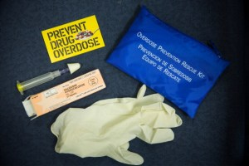
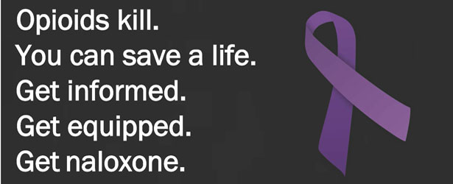
With so many people (hopefully) in attendance, there is an opportunity to educate and equip those who need it most – users and their loves ones. Overdose prevention/harm reduction is becoming a standard of care practice across the country. If your state has active policies allowing for the use of naloxone by laypeople and a Good Samaritan Overdose Law, we highly recommend facilitating a training during the event. If your state does not currently support this important harm reduction intervention, we encourage you to use the Rally as an opportunity to advocate for it.

Vendor and Information Tables
Set up a table with information about the opioid epidemic and how to recognize and reverse an overdose. Include copies of the FED UP! Platform and the Flyer for the September 18, 2016 FED UP! Rally in Washington, D.C. Let us know at feduprally@gmail.com if you would like us to send you flyers … or you can print them by using the artwork available at http://feduprally.org/wp-content/uploads/2016/03/2016-FED-UP-Rally-flyer.pdf.
Display information about the organizations that are helping to organize your Rally. Also, reach out to local addiction treatment centers and other groups and offer to provide them with a way to give out information about their organizations. This will be a great way to get more people involved and for you to stay connected with others in your community.

Candlelight Vigil
Consider adding a candlelight Vigil to the end of your rally. Provide candles (real or battery powered) to each person in remembrance of those lost. Once candles are lit, have a moment of silence. Music is often appropriate at a Vigil … perhaps the singing of “Amazing Grace. Last year there were several groups that had candlelight vigils during the day, so it is not something that can just be done after sunset. In some communities there may be groups that have held candlelight vigils on International Overdose Awareness Day in the past. If this is true in your community, we suggest that you reach out to the organizers to discuss combining the events.

Display empty shoes in remembrance of Lost Loved Ones
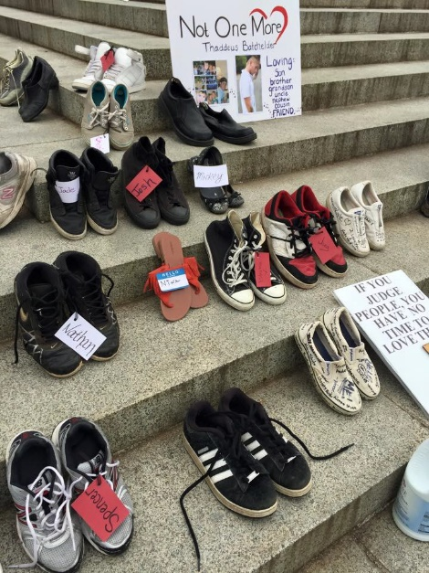
Consider encouraging participants to bring a pair of shoes to your Rally … in remembrance of their lost loved one. The shoes can be displayed on the steps of your federal building, or at another central location. The empty shoes are reminders of the tragic losses that have occurred due to overdose, and they memorialize the specific individual victims of the opioid epidemic.
To organize this effort, be sure to let your attendees know to bring a pair of shoes and then:

- On the day of the Rally, place the shoes in an organized fashion at the focal points of the rally such as around the stage (if you will have one), on stairs, around a monument or call out a specific area and develop your own display.
- Purchase tags at your local Michael’s or Hobby Lobby craft stores to attach to each pair and write the name of a deceased overdose victim on the tag along with the date of birth and date of death.

Sound System/Podium
If you plan to have music or speakers at your rally, you may want to plan ahead to find a sound system and/or podium. Perhaps the federal building will have a system you can borrow, or you can find another donated source. Having the FED UP! logo (available on the FED UP! website at http://feduprally.org/fedup-goes-local-2016/) printed on poster board to attach to the podium would cost about twenty dollars.
If your Rally will be small, there may be no need for a sound system … and small Rallies are just as important as big ones!

Banner
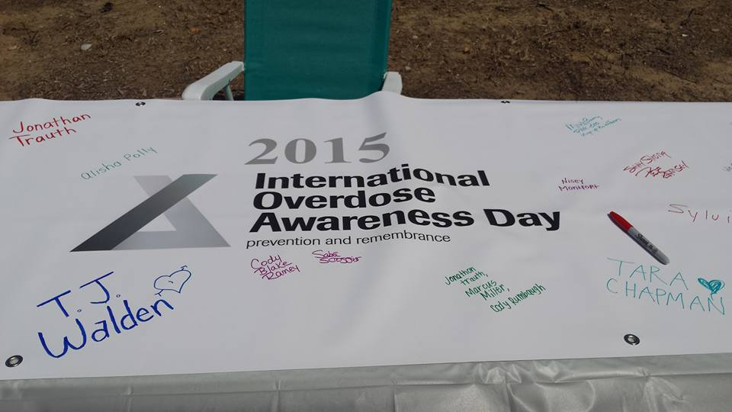
In addition to the FED UP! banner described in Part Two of this Toolkit, you might consider having a banner made at a local office supply store with the FED UP! and/or International Overdose Awareness Day logos as a way for attendees to sign in and write the name of their loved one on the banner. The FED UP! logos are on the FED UP! website as described above. Here is the International Overdose Awareness Day logo:

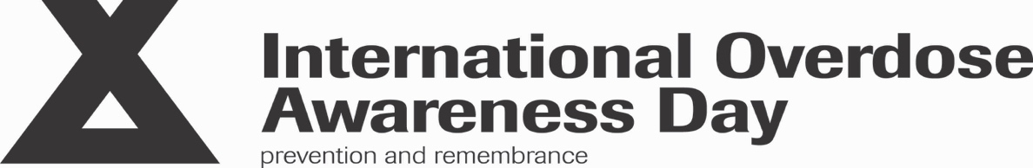

Be creative
Have paper cut outs of butterflies or birds with the names of those lost and hang them in the area. You could have an extra table for pictures of those lost and have people bring them to display during the rally.
Program
You could print a program to pass out to your attendees that would provide a timeline of activities and speakers. This could be a one-sided sheet to include just the timeline, or you could print a foldable program that would include the FED UP! Platform and other information important to your event. A sample program and the 2016 FED UP! Platform are included at the end of this part of the Toolkit.

We are grateful for your willingness to help with a FED UP! International Overdose Awareness Day Rally in your local area. These rallies, held simultaneously across the U.S. and Canada, will draw much needed attention to this public health crisis. While we are unable to help you with all of the details of planning your Rally, please feel free to contact us if you have questions about the information in this Toolkit. See the FED UP! Goes Local page of our website at http://feduprally.org/fedup-goes-local-2016/ to download copies of Parts One and Two of the Toolkit. Part Four will outline how to get press coverage and will include a sample press release. Part Four will be available when we are closer to the date of the Rallies.

Contact us with Questions:

Emily Walden, Co-Chair, FED UP! International Overdose Awareness Day Committee
Emily.walden@feduprally.org

Cindy Koumoutzis, Co-Chair, FED UP! International Overdose Awareness Day Committee
Cindy.koumoutzis@feduprally.org

Judy Rummler, Chair, FED UP! Coalition
judy.rummler@feduprally.org

Sample Program:
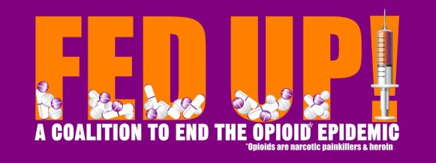

FED UP! Rally 2016

1:00pm to 3:00pm

Speakers:

Special Guests:

Activities:

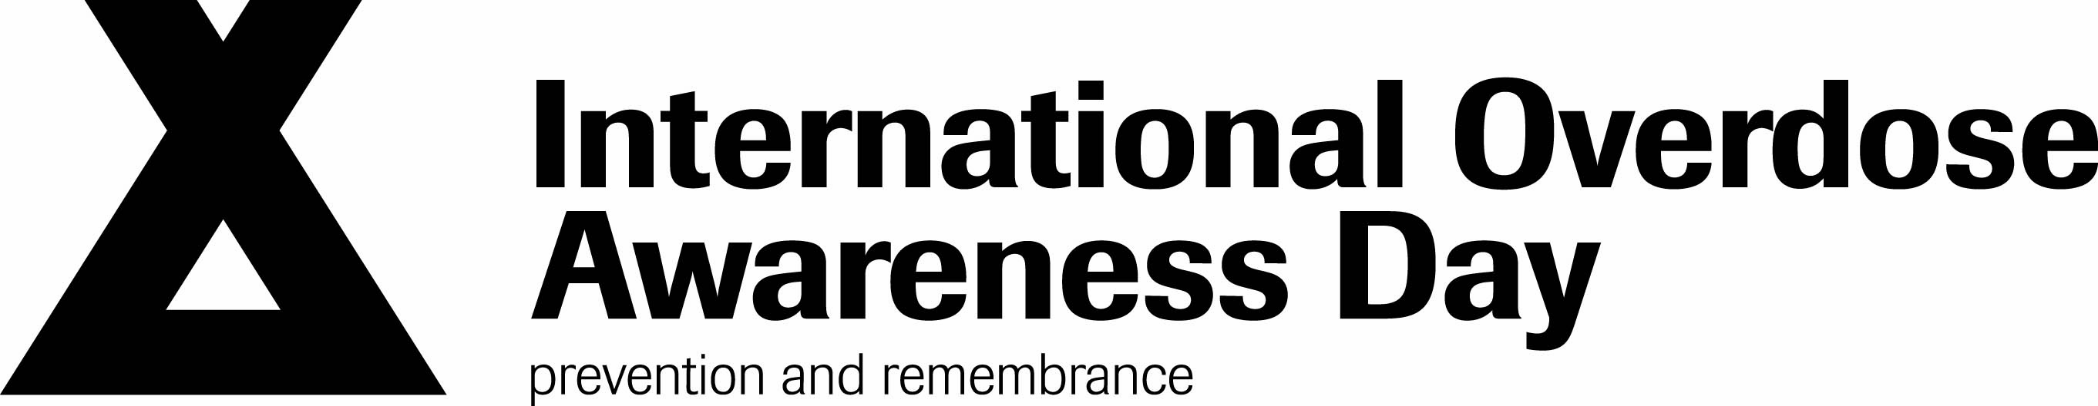
FED UP! Coalition to End the Opioid Epidemic
2016 Platform

- We are in the midst of a severe epidemic of opioid addiction and overdose deaths – acknowledged by the federal government as the worst drug epidemic in U.S. history.

- Overprescribing of opioids has harmed millions of pain patients and led to sharp increases in addiction, heroin use, injection-related diseases, infants born opioid-dependent, and overdose deaths.

- The epidemic is having a catastrophic impact on families and communities and is placing a tremendous strain on our health care system, workforce, and legal system.

- To date, the response from the federal government has been slow and tragically ineffective.

Together, we must find new ways to prevent opioid addiction, to ensure access to effective opioid addiction treatment and to reduce opioid overdose deaths.

To these ends, we – the FED UP! Coalition to End the Opioid Epidemic – call on our federal government to take the following actions:

- Take all measures necessary to ensure that opioids and other controlled drugs are prescribed more cautiously.
- FDA should take the following actions:
- Prohibit marketing of opioids for conditions where risks outweigh benefits.
- Consult its advisory committee before approving any new opioids.
- Add an upper dose and a suggested duration of use on opioid labels.
- Designate naloxone an over-the-counter drug.
- Ensure that abuse-deterrent opioid formulations are NOT marketed as less addictive.
- DEA should mandate prescriber education, free of industry bias, for all registrants who intend to prescribe more than a 3-day supply of opioids.
- HHS should immediately reduce barriers to buprenorphine treatment.
- Increase funding for evidence-based addiction treatment, especially in communities hit hardest by the epidemic.
- CDC and SAMHSA should improve public health surveillance of opioid addiction and overdose deaths.
- Incentivize states to mandate prescriber use of Prescription Drug Monitoring Programs.

These commonsense interventions could save countless lives
and help bring an end to this epidemic.

