FED UP! Rally Toolkit – Part Two

A Guide to Planning your 2016 local FED UP! Rally
(on International Overdose Awareness Day, August 31)

Promoting Your Local Rally

There are many effective ways to promote your event! Your target audience is broad and each relies on different sources for information. By utilizing a combination of the following marketing mediums, you are sure to get a great response:

Save the Date
Send out early save the date notifications on Facebook, email, twitter, etc.… to let people know you are planning an event for International Overdose Awareness Day. You can always update with details later. Registering your event with local calendars and with International Overdose Awareness Day at http://www.overdoseday.com/get-involved/register-an-event/ will help increase awareness of your rally.

Online -­‐ Event Page
There are great, user-friendly websites that will allow you to create FREE event pages so you can inform the public of all details and updates, promote it via social media and email, and sign up attendees and sponsors. You can even use it to track guest lists and any donations made by local sponsors! We highly recommend utilizing any of these:
- Eventbrite at https://www.eventbrite.com/
- Guestlist at https://guestlistapp.com/
- Picatic at https://www.picatic.com/
- Facebook at https://www.facebook.com/

Online -­‐ Social Media
Social Media is a powerful tool for spreading the word about your rally! The organic nature by which information travels via social media is the ideal way to recruit people to attend and participate in the rally as well as disseminate the FED UP! platform.
We recommend these steps:
- Find a volunteer to run the social media posts
- Reach out to current supporters of our cause including other advocacy organization or partners, and any sponsors or funding entities. Use social media to ask them to support and attend your rally.
- Twitter chat in early August with the hashtags: #rallytoendoverdose, #rallywithus, or
#fedup #overdoseawarenessday #endoverdosenow #ioad
- Post the FED UP! platform in small chunks on Facebook and Twitter
The Social Media Platform (Twitter and Facebook)
(available for download at http://feduprally.org/wp-content/uploads/2016/04/FED-UP-Goes-Local_The-Social-Media-Platform.pdf)

We ask you to tweet out and post the following on Twitter and Facebook to spread the word about your FED UP! International Overdose Awareness Day rally. These tweets and posts will help to get more people to your rally, and they will introduce the general public to our platform. The FED UP! Coalition’s platform consists of concise messaging which outlines solutions to this public health crisis.

Tweets – Twitter handle: @FEDUpRally
It's time to #EndOverdoseNow in {YOUR STATE}! {LOCATION,DATE} demand a federal response 2 #OpioidOverdoseEpidemic @FEDUpRally

78 die daily from opioid overdoses! #EndOverdoseNow by getting Naloxone into your home and police cars feduprally.org @FEDUpRally

Together we must prevent our children, friends, and loved ones from becoming addicted to opioids, join feduprally.org @FEDUpRally

We call on the @USAgov to allocate more funding for evidence-based treatment and prevention #joinup feduprally.org @FEDUpRally

feduprally.org calls on @US_FDA to prohibit marketing of #opioids for conditions where risks outweigh benefits @FEDUpRally

feduprally.org calls on @US_FDA to consult its advisory committee before approving any new #opioids @FEDUpRally

feduprally.org calls on @US_FDA to add an upper dose and a suggested duration of use on #opioid labels @FEDUpRally

feduprally.org calls on @US_FDA to designate naloxone an over-the-counter drug @FEDUpRally

We call on @US_FDA to ensure that abuse-deterrent #opioid formulations are NOT marketed as less addictive @FEDUpRally

If you would like to create your own unique tweets please do! Use feduprally.org as a way to link people to our full platform on our website and please use our twitter handle @FEDUpRally so we can re-tweet your tweets.

Facebook Posts
Posts on your Facebook page will draw attention to your Rally. Here are some sample posts. You can attach your flyer to your posts or attach one of the FED UP! logos available for download at http://feduprally.org/fedup-goes-local-2016/

Post #1
Now is the time to ensure that people suffering from opioid use disorder have access to affordable, evidence-based treatment! The FED UP! Coalition and {NAME OF YOUR ORGANIZATION} call on the Federal Government to make this a reality. Join us in honor of International Overdose Awareness Day at {LOCATION AND ADDRESS} on August 31, 2016 from {TIME OF EVENT}

Post #2
Are you FED UP with the lack of awareness/access to Naloxone in your community? 78 people will die today from a drug overdose that could have been reversed by this miracle drug. Join us {NAME OF ORGANIZATONS} for FED UP! Coalition’s International Overdose Awareness Day Rally at {LOCATION AND ADDRESS} on August 31, 2016 from {TIME OF EVENT}!

Post #3

The Opioid Epidemic has silenced too many voices due to death from drug overdose. The time is now for you to remember those gone too soon by asking our federal government to do more to support those suffering from substance use disorder. These are our children, siblings, parents, spouses, grandparents, friends, colleagues and fellow humans! Join us {NAME OF ORGANIZATONS} for FED UP! Coalition’s International Overdose Awareness Day Rally at {LOCATION AND ADDRESS} on August 31, 2016 from {TIME OF EVENT}
Post #4

The overprescribing of opioid painkillers has to stop. 8 of 10 heroin users started with pills. Support the CDC Opioid Prescribing Guideline for Chronic Pain. Join us {NAME OF ORGANIZATONS} for FED UP! Coalition’s International Overdose Awareness Day Rally at {LOCATION AND ADDRESS} on August 31, 2016 from {TIME OF EVENT}
Online -­‐ Email Blasts
Here is a sample email to send to current/past supporters and affiliated groups asking them to promote your Rally. Please attach the Social Media Platform which is available for download at http://feduprally.org/wp-content/uploads/2016/04/FED-UP-Goes-Local_The-Social-Media-Platform.pdf.

Hello Friend/Supporter of {NAME OF YOUR ORGANIZATION}:

We appreciate your continued support for the {NAME OF YOUR ORGANIZATION}! We hope you know about the FED UP! Rally we are organizing on International Overdose Awareness Day at {NAME OF LOCATION} on August 31st. The more attendees we have, the greater the chance we have of getting real change and support for our local communities. We are emailing you today to ask for your support in a new way. Please help us by spreading the word about the Rally via your social media.
We have taken the time to prewrite Facebook and Twitter posts that you can send out to your contacts. This would be greatly appreciated and would help us with our call for immediate and comprehensive action from our Federal Government to bring an end to our nation’s opioid epidemic.
Please review the attached “Social Media Platform”. If you have any questions, please reach out to {YOUR NAME} at {YOUR EMAIL ADDRESS} or {YOUR PHONE NUMBER}.

Print – Flyer

We have created a template in Word for you to use to create a flyer … or please feel free to create your own using one of the FED UP! logos available for download at http://feduprally.org/fedup-goes-local-2016/.

See Appendix C at http://feduprally.org/wp-content/uploads/2016/04/AppendixC_custom-flyer-TEMPLATE.docx for the flyer template. To use the template to create your own flyer, download it and use the designated areas to add information about your rally, including location (and address) and organizer contact information. We suggest that you “save as” PDF before distributing it electronically. If you need help, please let us know at feduprally@gmail.com. The flyer can be used for both online and print marketing. Send these flyers to your contacts to post on their websites and Facebook pages. Put them up in your local coffee shops, restaurants, and community boards, and give them to other agencies that interact with members of your community.
Print – Letters

Part One of this Toolkit included examples of letters/invitations that can be sent for outreach to potential rally attendees (Appendix A) and to legislators or other special guests (Appendix B).

Telephone

Social media and email blasts are not the only way! In fact, there is a very large community out there who is NOT social media savvy and prefers to communicate by talking on the phone or texting. Here’s a very basic sample phone script you can use when reaching out to invite people to your rally!

Hi, I’m [YOUR NAME] and I’m calling from [NAME OF YOUR ORGANIZATION]. How are you?
Wait for response.
We’ve been working in [NAME OF YOUR COMMUNITY] to let people know about our opioid and overdose epidemic, and we are planning a rally on International Overdose Awareness Day on August 31st. We will be calling for action to end the epidemic and to remember those we have lost to overdose. Would you be interested in attending or helping us spread the word?
If interested, explain how he/she can help.

====================================================================

Optional Promotional Materials and Displays

We know each rally is unique to the groups planning it! We also know that making it simple tends to be the best solution! So, we’ve made it as easy as possible for all groups across the U.S. and Canada to represent the cause and have supportive and BOLD materials and demonstrations at the event. Neither of the two options presented on the following pages is mandatory, but we strongly encourage each rally to order a banner and t-shirts to create a more unified presence across the country! Here is what you can do…….

FED Up! Coalition Banner

Having a Banner on display at your Rally will help to draw attention to the important platform of the FED UP! Coalition.

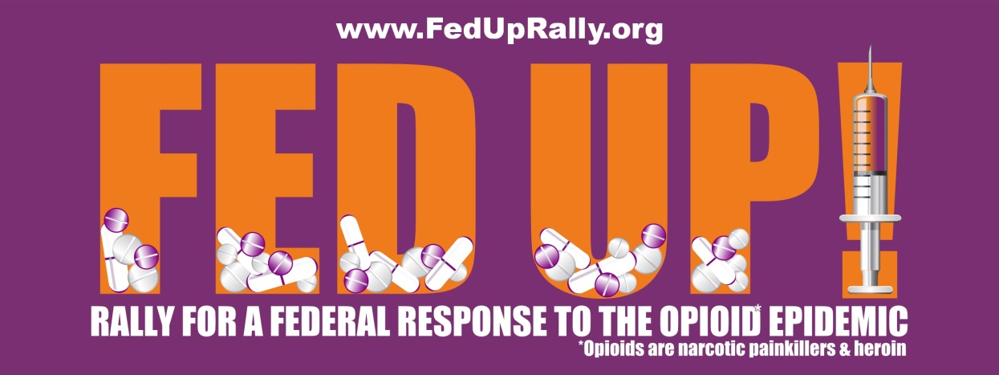

Here is information on how you can order a vinyl banner (as displayed above) that you will be able to use at your 2016 Rally … and future events too. The cost of the banner will vary ($30 – $50 plus shipping and handling) depending on current promotions.
Ordering Instruction:
See Appendix D at http://feduprally.org/wp-content/uploads/2016/04/AppendixD_3X8-FED-UP-banner-artwork.pdf for the full size banner artwork (a PDF file).

Banners are 3’ x 8’. We recommend ordering your banner through the following website - http://www.buildasign.com/CustomBanners. You may save money by calling the 800 number on the website and asking for a promo code. They often have sales running.

Here are step-by-step instructions for a successful banner ordering experience:
1) Save the banner PDF file to your hard drive.
2) Click the link above to go to the BuildASign website.
3) Enter your size (3’ x 8’) to the left of the “Start from Scratch” yellow button.
4) Click the “Start from Scratch” yellow button and a new window will open.
5) First, on the left side under “You are editing: Text” click the remove button to remove the existing text block.
6) Click “Upload Image”, and then click “Browse”.
7) A window will open from your computer, find the banner file and double click on it.
8) You will see the file name in the box, then click the blue “Upload Image” button.
9) The art will appear in the design box. Resize the image to fit the banner shape by dragging the bottom right corner all the way to the lower right corner of the banner shape.
10) When ready, click “Save and Continue”. You will have the opportunity to view a proof at this time.
11) Choose any finishing options that you desire such as Clear Tabs or Grommets for hanging, and consider upgrading the material if you want more durability.
12) Double-check your quantity.
13) When ready, click “Add to Cart”.
14) Continue with order by filling in your shipping and payment information.

If you prefer, you may also order a banner from a local sign or banner shop using the same PDF file. If you ordered a banner last year it will work perfectly again this year.

If you are struggling to find a donation to cover the cost of your banner, please let us know. We may have some extra banners to distribute on a first-come, first-served basis to organizers who send us an email at feduprally@gmail.com (and a mailing address) requesting a banner.

Official FED Up! Coalition International Overdose Awareness Day T-Shirts
A Fundraising Opportunity

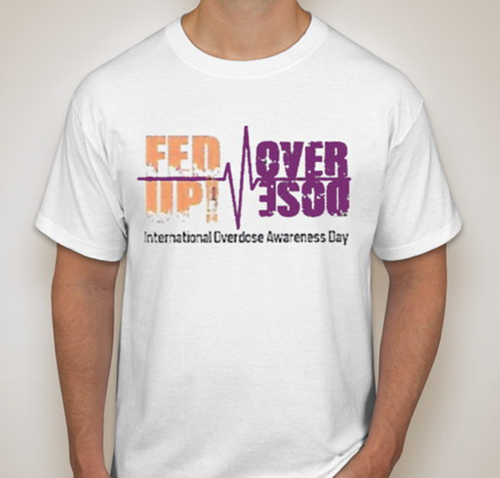
The purchase of International Overdose Awareness Day t-shirts for $20 each (plus shipping and handling) will raise funds to be distributed in September to you and other organizers of the local FED UP! rallies. Please distribute the link below to your attendees and also consider how you might collect and submit t-shirt orders on their behalf. Collecting t-shirt orders to be placed together and sent to a single location would significantly save on shipping charges.

Starting on June 26th T-shirts can be ordered at https://www.booster.com/internationaloverdoseawarenessday#

The Booster site for ordering these t-shirts will be live from June 26th through August 7th. The t-shirts will be shipped in mid-August directly to the address submitted by the person who places the order.

Contact Information

We are grateful for your willingness to help with a FED UP! Rally in your local area. These rallies, held simultaneously across the U.S. and Canada, will go a long way in drawing much needed attention to this public health crisis. While we are unable to help you with all of the details of planning your Rally, please feel free to contact us if you have questions about the information in this toolkit. We hope that it will be helpful. Part Three of this Toolkit will offer a suggested agenda for your rally and some ideas for activities to be included. Part Four will outline the importance of media involvement and how to get press coverage. Part Three is coming soon.

Contact us with Questions:

Emily Walden, Co-Chair, FED UP! International Overdose Awareness Day Committee
Emily.walden@feduprally.org

Cindy Koumoutzis, Co-Chair, FED UP! International Overdose Awareness Day Committee
Cindy.koumoutzis@feduprally.org

Judy Rummler, Chair, FED UP! Coalition
judy.rummler@feduprally.org

